**The Curlyssey**

**By Glen Austin**

Let me share a curling story. Truly, a part of Blind River Curling Club's history, but in another location. You might be familiar with "The Odyssey"... it's a poem by Homer. Homer was this ancient Greek poet who wrote these renowned works that became the foundation of Greek literature. One of these works was The Odyssey. It recounts the journey home of the King of Ithaca, Odysseus, after the Trojan War. I guess Odysseus and his comrades had all kinds of adventures on the road, as Homer recounts. Well, I can tell you of a time when 12 members of the BRCC had a bit of an Odyssey themselves. But it wasn't heading home after the Trojan War, but it was heading TO the very first ever Continental Cup of Curling to be held in Las Vegas. In fact, it was a BRCC CURLYSSEY.

It was 2014, and 18 BRCC members decided to attend the Continental Cup in Vegas. I mean, seriously, of course we did! 2 members flew out of Sault Ste Marie, On with Air Canada. The other 16, myself included, were to fly out of Kinross Airport in Sault Ste Marie, MI. So, on the night before we were to depart, we all holed up in Kewadin Hotel and Casino. We were near the airport, and we were all ready to go. Except for when 9 pm came and our flights were cancelled. Bad weather in Detroit would prevent the plane from coming to Kinross for the pick up. For 4 of the 16, not so bad, they got on a flight that left just 2 or 3 hours after the original flight time. However, for the remaining 12, myself included, we were not going anywhere for 2 days until we could be put on the next flight. So, with this being the case, we were staring down missing half of our time in Vegas and half of the Continental Cup. To say we were nonplussed is an understatement.

So, we gathered in my room and I got on the phone with Delta Airlines. I am willing to bet that the young lady on the other end of the line still remembers and recounts this story. So, initially nothing to be done. No

flights, no nothing. Options were to shuttle to Detroit ( 7 hours away) and try to reach our connection. It was tight. We would have to leave that night and drive toward a storm and hope to make it. Not a great option and what

shuttle? I had that girl on the phone for easily an hour, refusing to just let it stand and brainstorming for other options. As it was, there was another

option! Not the best, but AN option. There is a small airport in a small place called Alpena, Mi. It was approx 3 hours away from Sault Ste Marie, MI and to get there, you continue south along the coastline of Lake Huron. If we

could get there by 1 pm the following afternoon, we could catch the flight to Detroit and make our connection to Vegas. So, without any other hopes but this, we all changed our booking to take this flight out of Alpena. But, now the task is to get 12 of us to Alpena. We were unsuccessful finding a shuttle and despite our best efforts, it appeared our hopes were fading fast and this trip was a bust. It just so happened that we were standing at the Kewadin Hotel check in desk looking for shuttles and discussing our plight. As fate would have it, there was a newer employee working on the evening desk by the name of Louis. He was listening the whole time and wanting to help, he said that maybe he could set us up to use the Kewadin Shuttle Bus (just picks people up at other hotels in town and brings them to the casino) to bring us to Alpena, BUT, he could not authorize this and could only ask his boss, Tina, when she came in at 8 am. At that point, it was all we had. So, agreeing to be at the counter for 8 am sharp to meet Louis and beg Tina, we all went about our evening and tried to make the best of it.

At 7:30 am the following morning, myself and my pal (another of the 16), were at the counter with hopeful looks on our faces. Louis was there and as luck would have it, Tina was in early. Louis pleaded our case and by the grace of God (and Tina!), we were all loaded into the shuttle and it was off to Alpena for the happy 12! Enroute we laughed, we joked, we even sang a few bus songs, the sun was out and the world was at our feet. And then came these other times when it clouded over, and snow squalls came and practically white out conditions. Those were the times we sat quietly as the spectre of defeat loomed largely over our little shuttle full of hopefuls. And then the sun would come out again and more bus songs, even the driver sang along! And then more clouds, more snow, no singing, just sombre people hoping for the best. We rode that rollercoaster for 3 and a half hours and finally, we pulled into Alpena (not International) Airport.

Have you ever seen the show "Wings"? About these characters who work at a little airport? Well, Alpena Airport is like that, only smaller. We didn't care...we were just happy to be there. And we flew out of Alpena that day,

connected in Detroit and arrived in Vegas just 7 hours later than our original flight. We went on to attend all the games, we met other curling fans and

they even flew our BRCC banner. It was the best time ever! Many of those 12 are still members of BRCC and they will remember this time. It WAS a

CURLYSSEY alright and unlike Homer, this story will not form the foundation of anyone's literature, but I can tell you that it will be a memory retold many times in many different ways by 12 different people. Special times in curling. And that banner? Well I can tell you that it has attended The Scotties, Grand Slams, and Briers. A trip to Vegas return? $1200.00. Shuttle to Alpena? $400.00 usd...(combined our tips for driver). Tickets to Continental Cup$ 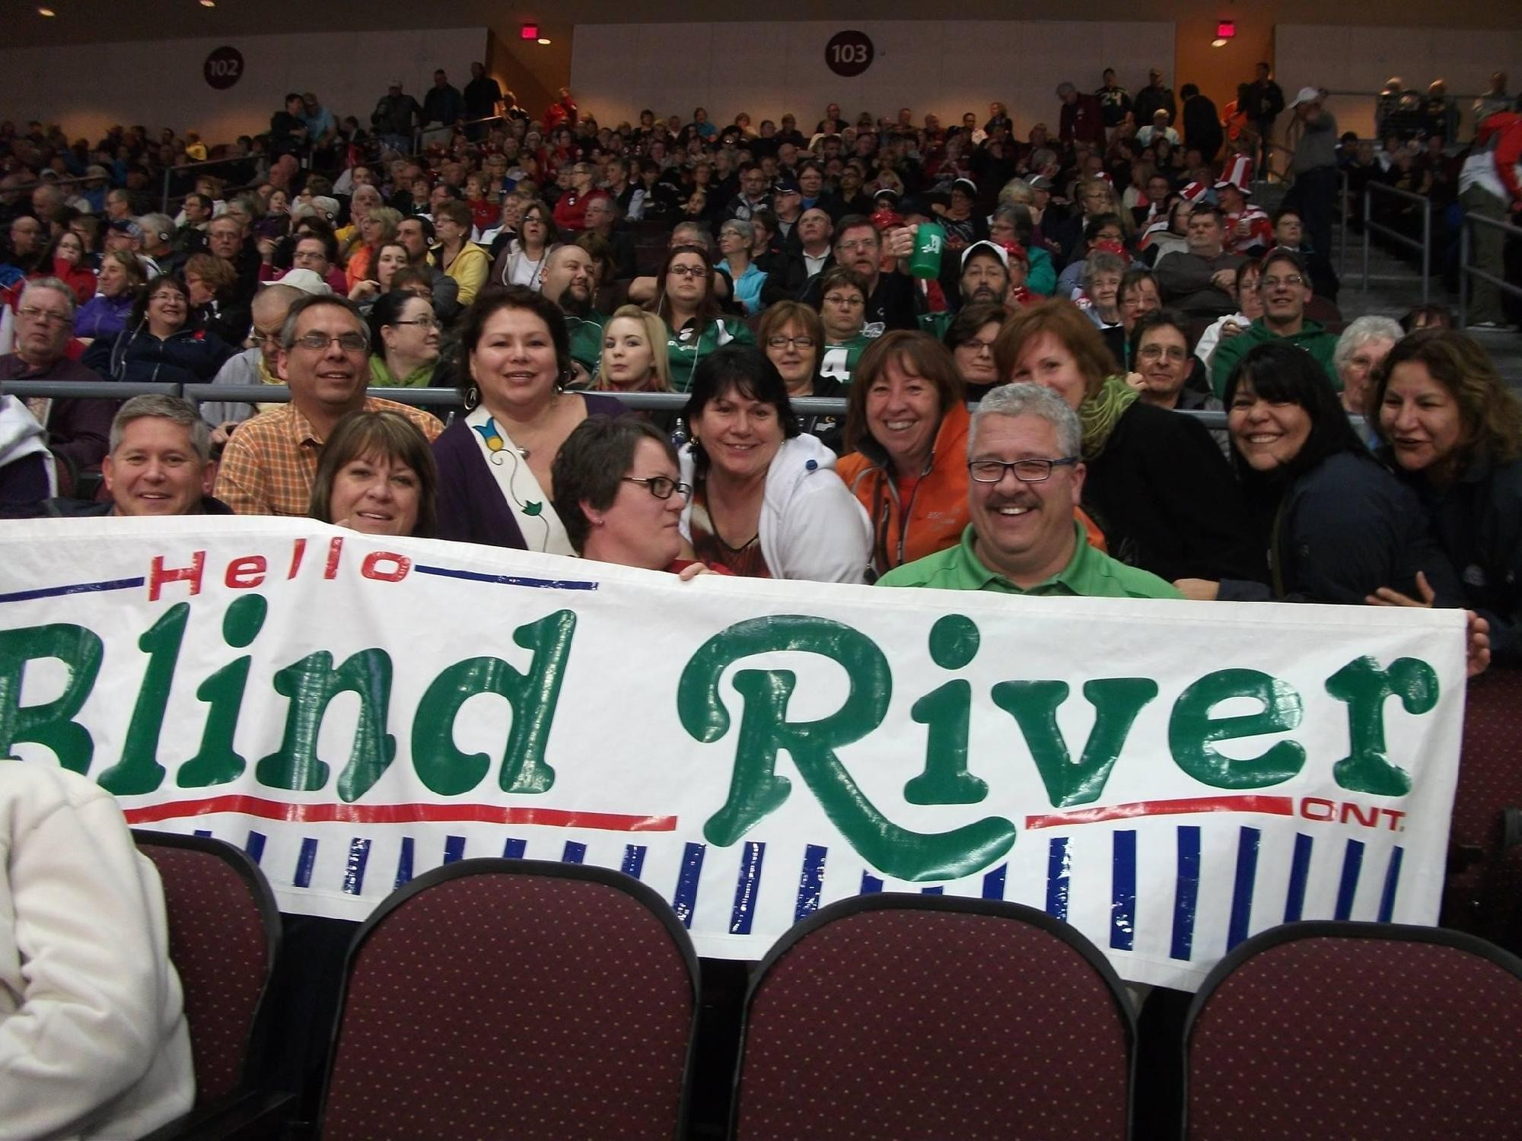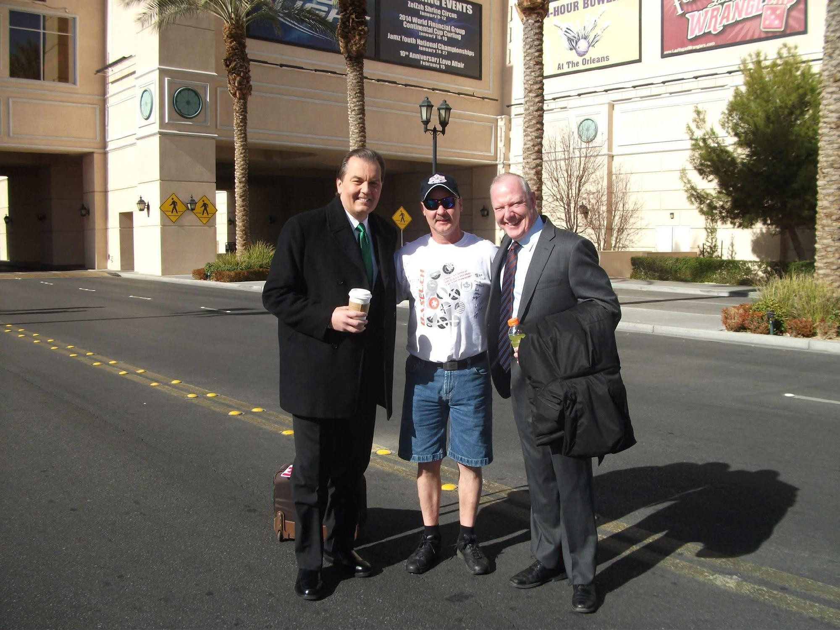$650.00. Great curling memories? Priceless